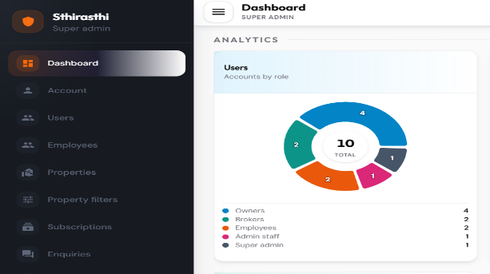
In the Dashboard, the Tenant role needs to be added to the analytics. Please check.
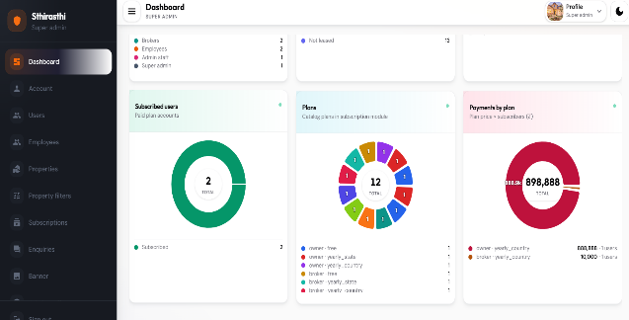

In the Dashboard, for the Subscribed Users pie chart, it is unclear which module users are being shown. Please update or remove the pie chart.
-> For “Payments by Plan,” tenant subscriptions also need to be displayed.
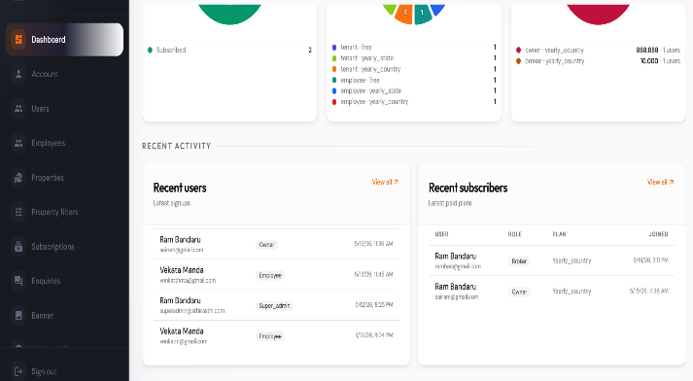
For Recent Subscribers, please show tenant plans as well.
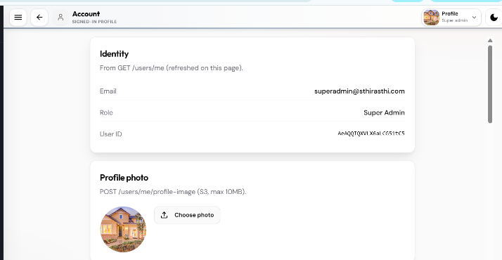

In Account Screen, Remove the unwanted format titles
No need of displaying user ID

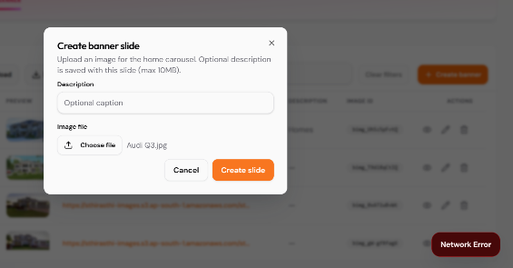

Admin is unable to create a banner. The system is displaying a "Network Error" message. Please check and update.

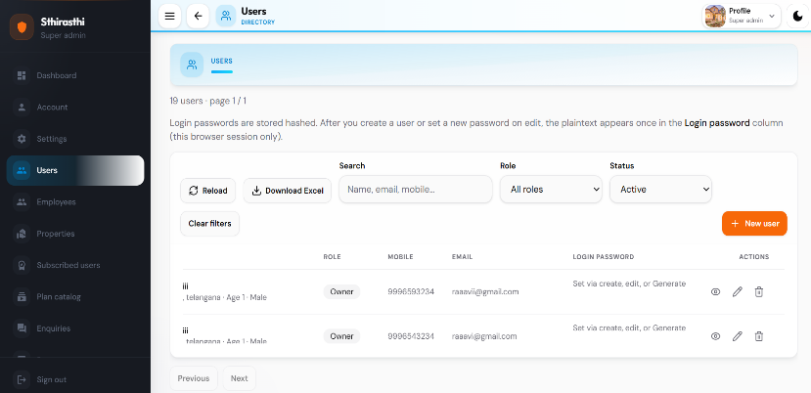
- Update pagination and display only 10 users per page.
- Comment out/disable the New Users Creation option.
- Provide proper page-level scrolling. Currently, scrolling is limited to the table; it should be applied to the entire page.
- Remove unwanted text/content from the screen.
- Ensure the table header row remains fixed/sticky while scrolling. Currently, the header row disappears when the admin scrolls the page.
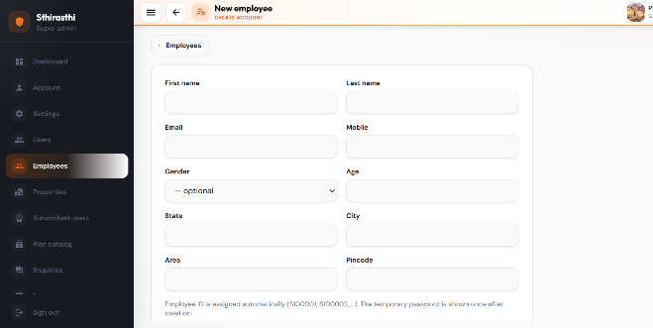
In the New Employee Creation screen, the Submit button is not visible. Additionally, the page is not scrollable.
Kindly check and update the functionality to ensure proper page scrolling and visibility of the Submit button.
- Mobile Number: Should accept only numeric values, should not allow alphabets or special characters, and must be restricted to a maximum of 10 digits.
- PIN Code: Should accept only numeric values and must be restricted to a maximum of 6 digits.
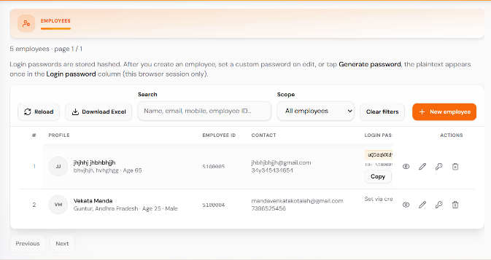
- In Employees screen, Remove unwanted text/content from the screen

- Ensure the table header row remains fixed/sticky while scrolling. Currently, the header row disappears when the admin scrolls the page.
- Update pagination and display only 10 users per page.
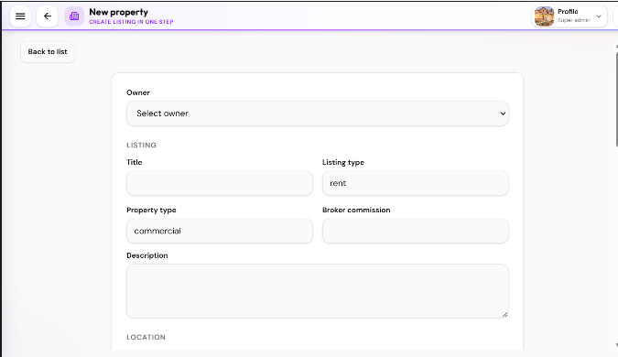
For the Add New Property, as per the UI, several required fields are missing in the Admin Panel. Kindly review the UI and add all the missing fields accordingly.
Additionally, please maintain consistency between the App and Admin Panel in terms of fields, flow, and functionality to ensure a seamless user experience across both platforms.

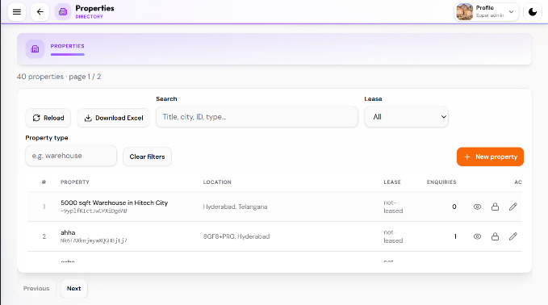
- In the Properties Screen, Ensure the table header row remains fixed/sticky while scrolling. Currently, the header row disappears when the admin scrolls the page.
- Provide proper page-level scrolling. Currently, scrolling is limited to the table; it should be applied to the entire page
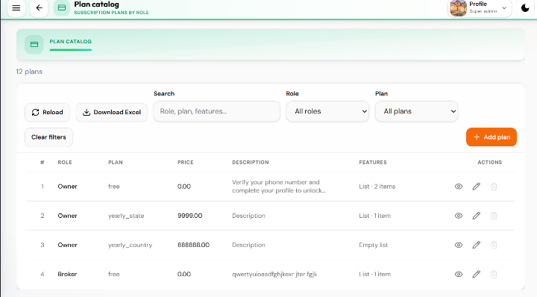
The Plan Catalog for the Owner Module needs to be updated according to the approved subscription rules. Kindly review the subscription logic and update the plan configurations, pricing calculations, property limits, and related functionalities accordingly.
- Ensure the table header row remains fixed/sticky while scrolling. Currently, the header row disappears when the admin scrolls the page.
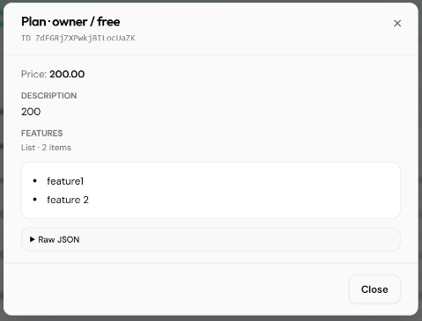
In the View Plan screen, there is no need to display the ID and unnecessary text such as "Raw JSON." Please remove them.

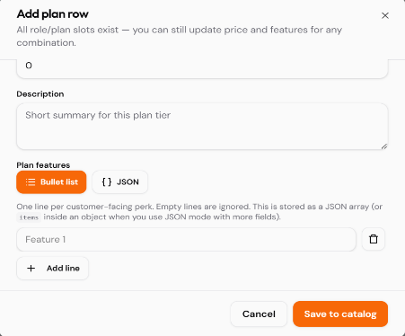
In the Add Plan page, there are several unnecessary labels and text elements being displayed. Kindly remove all unwanted wording and keep only the relevant fields and information.
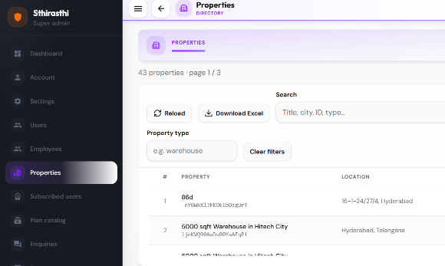

In the Property List screen, remove the Property ID from the listing. It is not useful for Admin Panel users. Instead, display meaningful property information such as Property Type (e.g., Hospital, Hotel, Warehouse, Apartment, Villa, etc.).

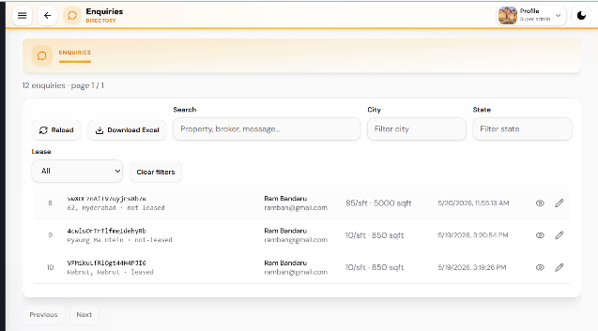
In the Enquiries screen, under the Property column, there is no need to display the Property ID. Instead, display the Property Title.
- Ensure the table header row remains fixed/sticky while scrolling. Currently, the header row disappears when the admin scrolls the page.
- Provide proper page-level scrolling. Currently, scrolling is limited to the table; it should be applied to the entire page
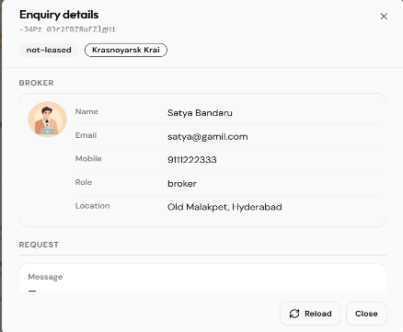

In the Enquiry View page, remove unwanted content such as the ID and unnecessary wording.

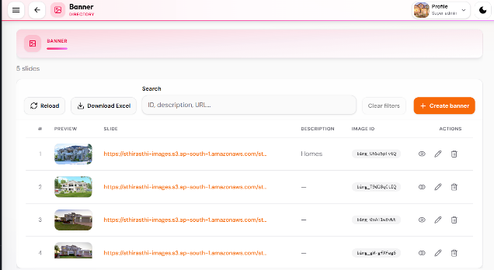
- In the Banner screen, remove the Slide column and Image ID, as they are not required. Instead, display the Banner Title for a better user experience.
- Provide proper page-level scrolling. Currently, scrolling is limited to the table; it should be applied to the entire page
- Ensure the table header row remains fixed/sticky while scrolling. Currently, the header row disappears when the admin scrolls the page.
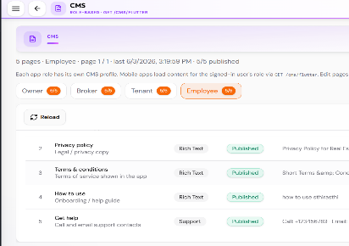
- View icon was not functioning please check
In the CMS screen, for the Employee Module, the Profile page in the approved Figma design does not contain the fields "How to Use" and "Get Help."
- For now, comment out/disable these options from the admin panel
- Remove unnecessary content from the screen on top.
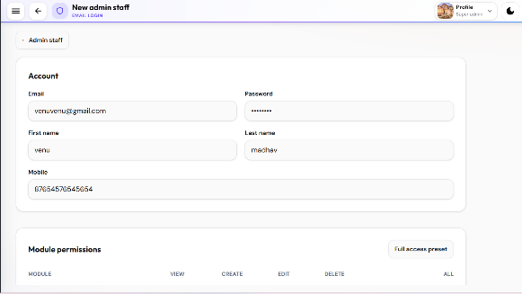
- In New Admin Staff screen, user unable to scroll the page please check
-> Please provide validation for the Mobile Number field to allow only 10 digits.

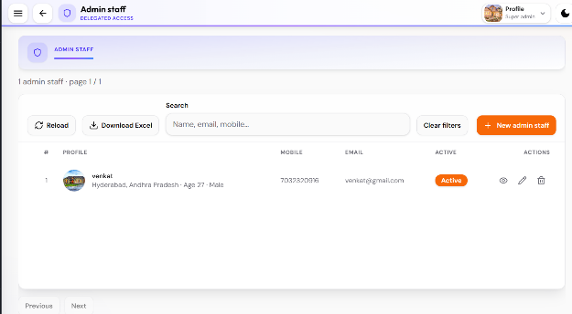
The title "Admin Staff" should be updated to "Role Management" throughout the application.
- Please add a Role column so that the Super Admin can easily identify whether a user is a Staff Member or Super Admin.
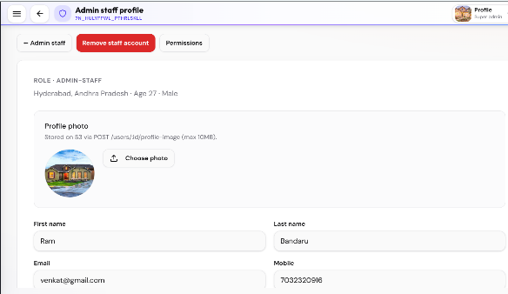
In View Admin, remove the unwanted text from the screen under Profile photo
- Remove the Staff Account and Permission buttons from the top section and place them inside the respective container, right side beside the Role/Admin Staff heading.
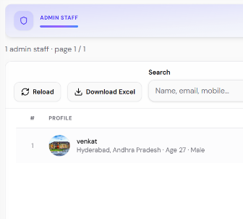
- The edited changes are not being reflected in the listing screen. For example, the user's name was updated to "Ram Bandaru", but the list screen is still displaying "Venkat".
Kindly check and update the edit functionality to ensure that the latest changes are saved and displayed correctly across all screens.

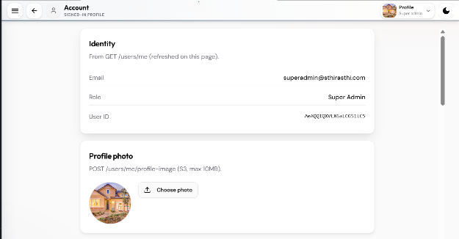
In the Account Screen, remove the unwanted text displayed below the Identity title, including User ID and the text shown under the Profile Photo section.

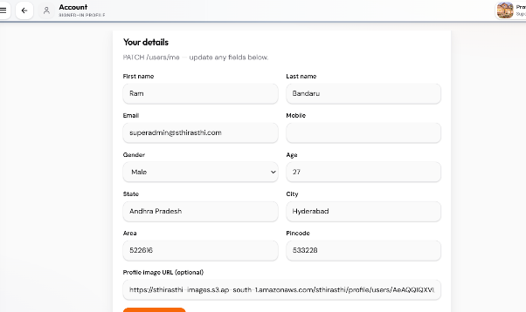

Also, remove the unwanted text displayed under the Your Details section. Additionally, remove the Profile Image URL field from the container and provide an Image Upload option instead.

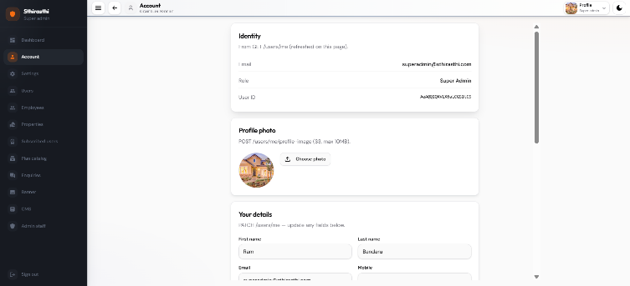
Please provide user responsiveness when user decreases the screen size (zoom out) for the screen Account, Settings, Users, Employees & Add New Employees, Properties & Add new Properties, Subscribed Users, Plan Catalog, Enquiries, Banners, CMS Screen, Role management & Add Admin Staff Screens.

